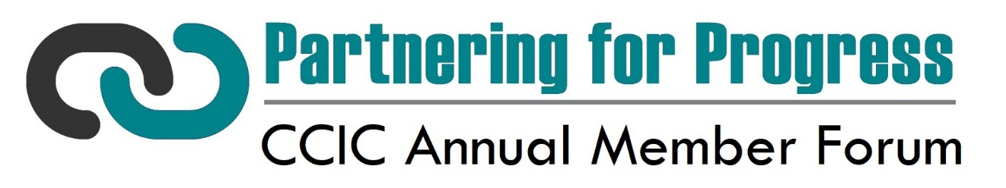
2022 Annual Member Forum Presentation Proposal

(*Denotes Required Fields)
Presenter #1
Name*
Company*
Email*

Presenter #2 (if applicable)
Name
Company
Email

Workshop Details
Workshop Title (a great title is important to drive audience registration): *

Please provide a workshop description for the brochure. (60 words max.).*

Workshop Audience (please select all that apply):*
- Academic  - Career Services  - Communications  - Facilities  - Fiscal  - Government Affairs  - Human Resources / Benefits | - Legal  - Risk Management  - Student Affairs  - Tech/Research  - Other

Please indicate all workshop timeslots in which you are able to present. Only one will be assigned, but we appreciate your flexibility as we work to schedule the workshops to best align with the first choice selections of the attendees. *
- 9:00 a.m. - Session 1
- 10:00 a.m. - Session 2
- 11:00 a.m. - Session 3

Below, please briefly highlight your main objectives and what skills or knowledge participants will gain as a result of your workshop:*

Is there anything else you would like us to know about your workshop?

